Infomgmt 192 – Lab Test 2 – njad144

1. Connected our URL variables to the one specified, shown below: 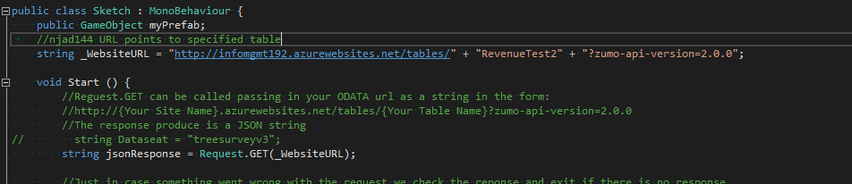  
     
   I also created a RevenueTest2 class file to be used later after the object is parsed. I did not include any of the default Azure easy table columns as it would be of no use to us, instead I focused on a class that had important and usable information to be parsed by our deserializer.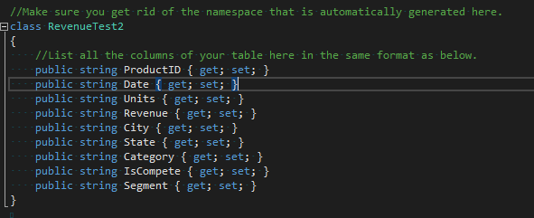
2. Modified the script to create cube for each row in this new class we have specified.  
   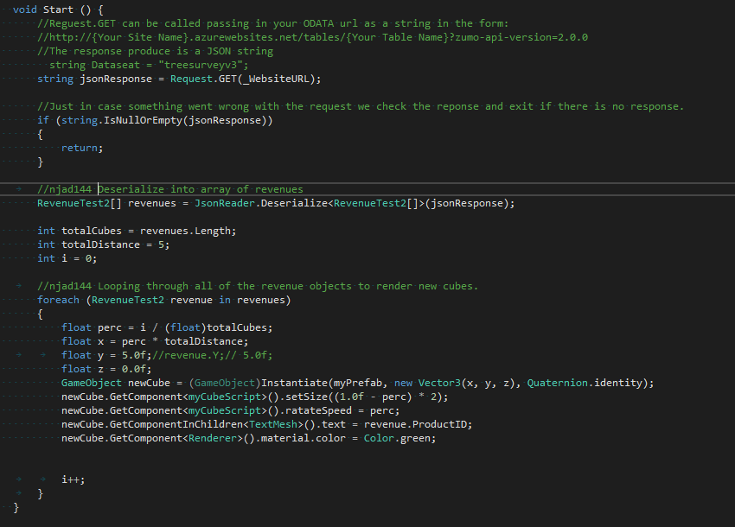
3. Instructions read and changed text to display city on the cube.  
   
4. Height was set to a fixed float of 5.0, I may change this later on to be a random float between say 3.0f and 8.0f so that we don’t get much overlap using: Random.Range(3.0f, 5.0f); but for now I have left it as 5.0f.   
   
5. Looking through the JSON provided, it appears that category can only be either Mix or Urban. Therefore this switch case was created to set colours depending on the category given.  
   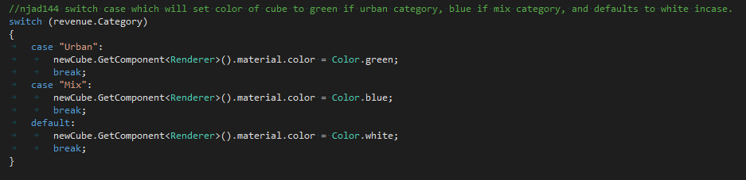  
   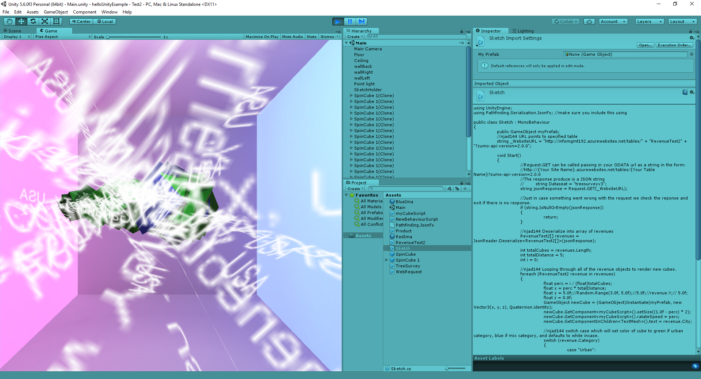  
     
   At this stage the visualisation is very clumped up and untidy. But it is creating cubes depending on the number of RevenueTest2 objects and displays the city variable on the cube. It also is setting colour depending on the category of the object/row.
6. Code implementations to limit to simply 10 cubes being rendered were made, and ensured that rotation of cubes happened within a -5.0 to 5.0 range along the x axis as shown below.  
     
   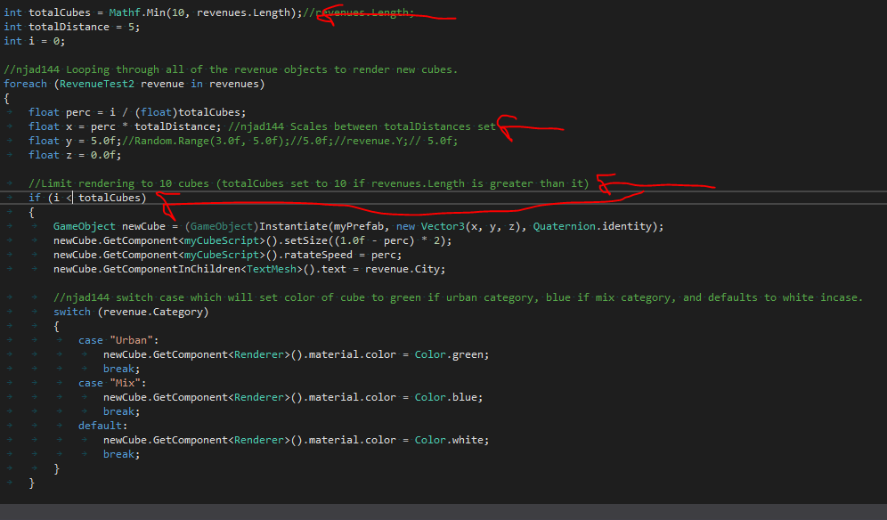  
     
   I also set the text character size to be smaller scaled so that it is actually readable on the cubes as shown below along with the visualisation.   
     
     
     
   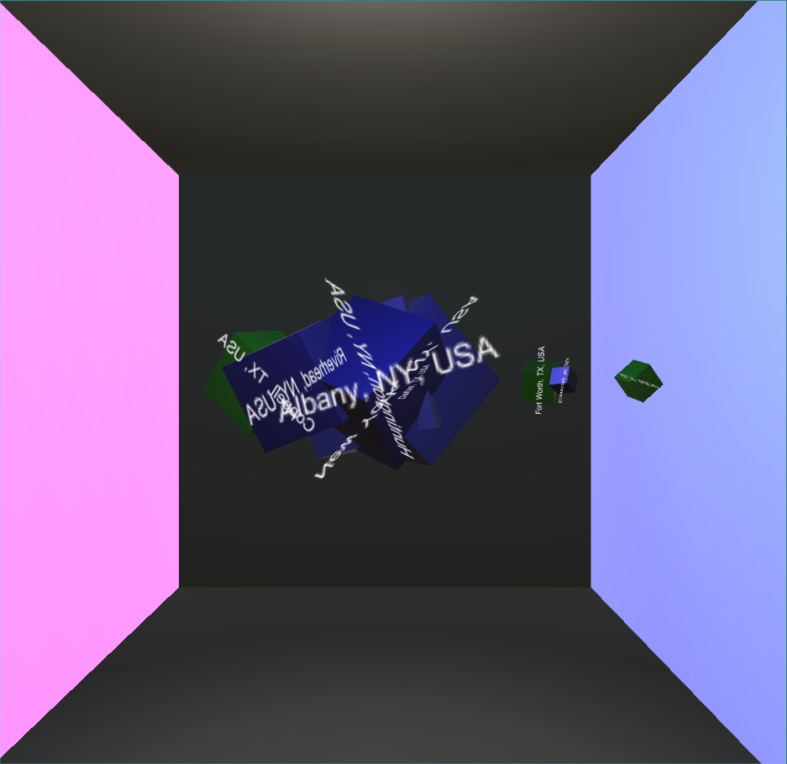  
     
   We can now see that the cubes are limited to 10 renders and the text size has been reduced so it is readable per cube. Also that every cube is either blue or green depending on its category.
7. Three syncs were done with the github project at this link: <https://github.com/njad144/Infomgmt192---LabTest2/>   
   The screenshot below also shows the 3 main commits that were synced up.  
   